## Basics

* operating system
* free
* open source

### History

ken Thompson early 70s UNIX

MULTICS

UNICS

UINX

Linus Torvalds early 90s Linux

Richard Stallman Open source

Next → darwin

### standards

sys V

BSD

### Open source

1. sell the ice-cream, recipe secret
2. sell the ice cream, recipe public
3. free , recipe secret
4. free on sundays, recipe public

firefox

GIMP

Blender

Audacity

Wordpress

Linux

### Unix based systems

Solaris

AIX

Darwin

HP-UX

Xenix

FreeBSD

### Linux based

GNU

Red Hat Linux 1994

OpenSuse

Linux Mint

Fedora Core

Debian Linux

Elementary OS

Arch

Kali Linux

BOSS

Ubuntu

unix-like or linux

## shell

command line interpreter (CLI)

terminal

command prompt

sh

ksh

csh

tcsh

zsh

Fish

bash

### prompt

username@hostname folder

john khut ~

$ normal

>

# root

### command structure

ls

ls -l

command options arguments

command arguments options

## Linux Architecture

### kernel

* core component

process management

creating, scheduling, termination

memory management

allocation, deallocation

device drivers

communication between operating system & hardware devices

system calls & support

interface for user applications to interact with the kernel

### system libraries

special functions

glibc

### system utilities

ls cp

ifconfig top

### user applications

web browsers

text editors

office suites

game

### shell

cli

### File system structure

inverted tree structure

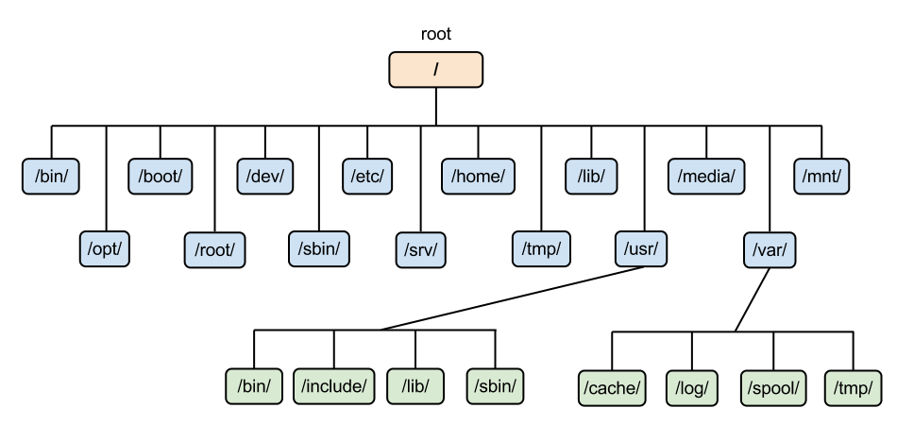

/bin essential command libraries

/etc configuration files

/home user home directory

/lib shared libraries & kernel modules

/usr user utilities & applications

/var variable data files (logs, databases etc.)

/dev device files (device drivers)

### /bootloader

loads the kernel into memory

GRUB

LILO

## basic commands

ls

-l long listing

-a all

pwd

print working directory

clear

clears the terminal screen

date

cal

bc

cd change directory

cd name

cd ..

parent

### getting help

#### whatis

#### man

b

f

search

/text

n next selection

shift+n previous selection

#### - - help

pages

1 user commands

ls

2 system calls

3 library calls

printf

4 special files

/dev

5 file formats & conventions

6 games

7 miscellaneous

signals

8 system admin

## files & directories

parked

boot flow